**Name: _______________________________________**

**Python Activity 11: Predefined/Built-in Functions**

|  |
| --- |
| **Learning Objectives**  Students will be able to:  *Content:*   * Explain the purpose of a predefined/built-in function * Explain the functions: abs(), pow(), int() round(), random * Explain the math library functions: floor() and ceil() * Explain the use of the **import**  statement * Explain the purpose of a function argument   *Process:*   * Write code that uses predefined functions   **Prior Knowledge**   * Python concepts from Activities 1-10 |

|  |
| --- |
| **FYI: Predefined/built-in functions:** segments of code already included in Python.*print(), round(), abs(), pow(), int()* are ***examples*.**  **Arguments:** The information that a function needs to work. Arguments are sent to the function between the parentheses ().  To use a function, **call** the function. **input(“Enter your name”)** is a call to the ***input*** function sending the string “Enter your name” as an argument. |

**Critical Thinking Questions:**

1. Circle calls to predefined functions in the following program.

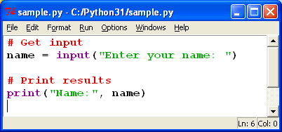

Circling doesn’t work. It is print and input

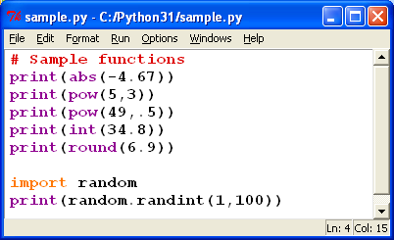2. Enter and execute the Python program on the right.

a. What is the output for each statement ?

* print(abs(-4.67)) 4.67
* print(pow(5,3)) 125
* print(pow(49,.5))7.681145747868608
* print(int(34.8)) 34
* print(round(6.9)) 7
* import random

print(random.randint(1,100)) 37

b. What is the difference between the round() function and the int() function?

int prints the whole number listed without the decimal, Round rounds to the nearest whole number.

3. Each of the following function calls return a value. What is the value returned for each line of code? Verify your answers by executing the code.

a. abs(4.5) 4.5 b. int(“678”) 678

c. round(-5.6) -6

d. import random

random.randint(4,10) 4

What is the purpose of “import random”? What happens if you omit that line of code?

It is a library not included in base python that was created by a person. Importing it adds the code so you can use it. But in a way that’s easier than making the code yourself and you cannot see how it works. When omitted ”NameError: name 'random' is not defined”

4. Circle the **argument** in the call to the built-in function:

number = 45.78

answer = round(number)

5. **answer = pow(4,3)**. What is/are the argument(s) in this code? (4,3)

6. If a function contains more than one argument, do you think the order of the arguments makes a difference? Explain your answer with an example.

Yes it does. Using the range(). The first number is the one to start on, then the end number, than the increments it increases in.

7. Execute the following lines of code:

import math

x = 4.7

y = 5.3

z = -4.8

a = -3.2

print(math.ceil(x))

print(math.ceil(y))

print(math.ceil(z))

print(math.ceil(a))

print(math.floor(x))

print(math.floor(y))

print(math.floor(z))

print(math.floor(a))

1. Explain the purpose of the **ceil()** function.

It automatically rounds up regardless of the decimal value.

1. Explain the purpose of the **floor()** function. It automatically rounds down regardless of the decimal value.

c. Why are the calls to the **floor()**  and **ceil()** functions preceded by “**math.”?**

In case another library has functions by the same name they are differentiated so only the correct one is called.

8. Enter and execute the following code:

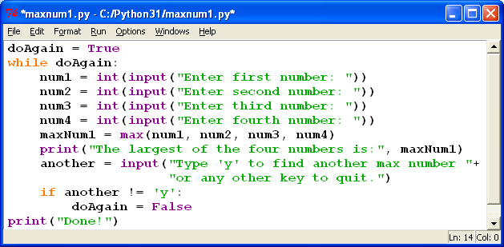

a. What type of variable is ‘doAgain’? boolean

b. What does the program do? tells you the highest umber you have entered.

c. What does the following line of code do?

**maxNum1 = max(num1, num2, num3, num4)**

determines the highest value number.

d. Experiment with the arguments in the **max()** function in the program to determine if the function must have four arguments. Provide an example for your answer.

Max needs 2+ arguments to work. Max(10, 7) the max number is 10

e. What does the following code in the last two lines of the program do?

if another != 'y':

doAgain = False

if the user enters anything but the letter Y the program terminates. Otherwise they would go forever.

**Application Questions: Use the Python Interpreter to check your work**

1. Write a line of code that prints the integer portion of the number 21.45.

int(21.45)

1. Write code that prompts the user for a floating point number and prints the smallest integer that is larger than the number

num = float(input("Enter a number with at least as one decimal point"))

import math

print(math.ceil(num))the user entered

3. Write the code to print a random number between one and six.

import random

print(random.randint(1,7))

if you want to include 6 as an option its (1,7) if you don’t want 6 as an option do (1,6)

4. Assume that a user enters any number and that the number is stored in the variable **userNumber**.

Write a line of code that converts the input to an integer. Then write a line of code that prints the positive value of the user’s input.

userNumber= int(input("Enter a Number: "))

if (userNumber < 0):

print(userNumber *-1)

else:

print(userNumber)

5. Write a line of code that calculates the square root of 900 and stores the result in the variable **answer.**

**import math**

**answer = math.sqrt(900)**